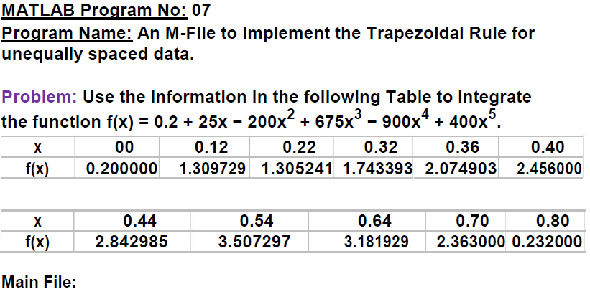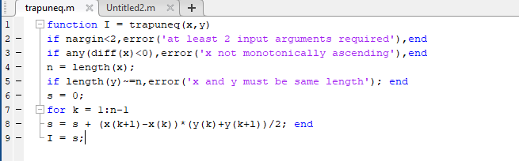

**Input File:**

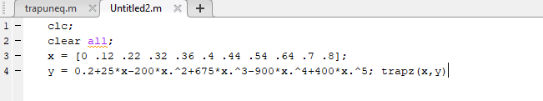

**Output:**

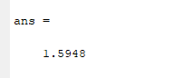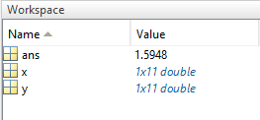

**Question: 1**

1. **Compare the above program with previous program (Matlab Program No:06)**

**ANS:** In lab Experiment 6& 7 both equation is solved by trapezoidal rule. But there has some difference between matlab program of them. We see from program of them that, in program 6, minimum 3 variables are needed where in program 7, minimum 2 variables are needed. And for program 6 upper bound must be greater than lower bound (b>a), where in program 7, x and y must be same length. And in both program for loop will be continued from 1 to n-1.

**Question: 2**

**2. Is it possible to implement Trapezoidal rule for equally spaced data by the above program?**

**Ans:** yes it is possible to implement Trapezoidal rule for equally spaced data by the above program. Actually to improve the accuracy of the trapezoidal rule is by dividing the integration interval from a to b into a number of segment and apply the method of each segment. Dividing the interval into equally spaced based points ( X0,X1,X2……….,Xn), gives n segment of equal width h